# I. Introduction

## 1.1 Background and Restatement of the Problem

A fierce natural disaster often changes the local living condition dramatically. Highway collapses, electricity shutdown and communication interruption bring a lot of difficulties to rescue and relief work after the disaster. As an aerial carrier, UAV has a flexible property which can allow it play different roles with different equipment such as materials transportation and reconnaissance of affected areas during the disaster relief action. But in what way can we deploy the drones and associated disaster relief resources to meet needs of affected area at the most? To solve this problem, we will design an Aerial Disaster Relief Response System for Puerto Rico, hit by Hurricane Maria in 2017, to achieve the following objectives:

* Determine the required number of containers and their location.
* Deliver the target medical supply to certain hospitals.
* Explore the major roads and highways which were affected by the disaster.

## 1.2 Assumption

* Containers should not be kept away from the road, otherwise it is not convenient to transport.
* The container should be located in the outskirts of the city, which is convenient for the daily management of related personnel, and can also avoid the risk of disasters.
* The medicine and the drone can be turned over at the time of packing, and the cargo container has no volume and is sufficient for the transportation task.
* When the drone is flying, as long as the weight of the cargo is within the load range of the drone, it is considered to have little effect on its battery life.
* The drone will fly in accordance with the road network when performing exploration missions. The drone must be recycled and cannot be recharged after being recycled. In other words, a drone can only perform one route of the scheduled delivery process.
* The drone only explores the main roads, ignoring the flight height limit, and can fly straight to the destination.

## 1.3 Our Work

* We selected three locations to place containers so that the drone system covers as many road networks as possible while meeting medical needs.
* Optimizing the packing method for each container.
* Provide delivery routes, schedule and a drone flight plan.



**Figure 1:** Modeling Process

# II. Preparation of the Models

|  |  |
| --- | --- |
| Symbol | Description |
|  | box quentity |
|  | BPS sequence |
|  | the probability of select bigger fitness |
|  | the probability of ignoring crossover |
|  | the probability of mutation |
|  | longitude distance |
|  | latitude distance |

# III. The Model

During our empirical analysis, we find that the most complex problem is how can we arrange the position of drones and associated medical supply in an ISO cargo with minimized unused space or the so called three-dimensional bin packing problem. In this section, we will illustrate a modified Genetic Algorithm, which is also the key point of our model, to prepare for our further interpretation.

## 3.1 Modified Genetic Algorithm

We consider to packdifferent rectangular boxes, drones and medical supplies in our model, into a identical rectangular bins (OLS standard containers) so that the bins` utilization ratio is maximized or equivalently, the bins` unused space is minimized.

R Language has been chosen to implement this algorithm. On the one hand, we can use the RGL package to draw 3D images. On the other hand, R is an open resources software.

Our model combines genetic algorithm (GA) and heuristic strategy. The heuristic packaging strategy applies the concept of maximum empty space to allocate the empty space in the container and select the layout combination according to the matching criteria. The heuristic packaging strategy generates the packaging scheme based on the given box Packaging sequence (BPS) and Container loading sequence (CLS). Genetic algorithms are used to evolve such sequences. Essential elements of genetic algorithm consists of chromosome coding, crossover, mutation and selection. We design solutions in consider of practical situation to adapt these basic elements to specific problems. Figure 2 illustrates the algorithmic framework. We will discuss the key factor of the algorithm in this part.



**Figure 2:** Genetic Algorithm

### 3.1.1 Chromosome Encodings Scheme

One chromosome has two part. The box packing sequence (BPS)and container loading sequence (CLS). We use order based encoding scheme to present the sequences. In our mode, sequenceis equal to 1. Sequenceis shown as follow:



Whereis the number of boxes.

### 3.1.2 Population Initialization

The initialization process follows the one used by Wang, H and Chen, Y[1]to heuristically generate some particular chromosomes in first generation. This process is based on the observation that the bigger products should be packed into the box earlier. Gene sequenceare generated by descending according to the value of volume, length, width and height of each products respectively. The rest individuals in the first generation are generated randomly.

### 3.1.3 Selection

We use the tournament method to chose chromosomes. The number of a generation is defined as population (POP). A individual in the population corresponds to a certain chromosome. They are sorted in descending fitness order. The fitness of a chromosome is given by a heuristic packing strategy which is described in section 3.2. First E chromosomes are selected as elitism which directly proceed into the next generation. POP-E parents are selected into the mating pool using the tournament selection method with the tournament size equal to 2(shown in the following function). When the fitness ofis bigger than the fitness of.



We select successive two chromosomes in the mating pool as parents. For each pair of parents, there is a probabilitythat they go directly into next generation, otherwise two offspring are generated through crossover.

### 3.1.4 Crossover and Mutation

Unlike binary encoding scheme that facilitates simple crossover operations like one-point crossover where gene strings are simply swapped with single cut point, designing crossover operation for order based encoding scheme is not such straight forward. We operate the crossover as follow. Two cutting points are randomly selected for the gene sequence, say i and j. Parentsandwill generate two offspringand.Child`s genes sequenceare generated as follows, genes at positions fromtoare copied from. Other positions inare filled with missing genes start from j+1circularly. The missing genes is obtained by sweepingcircularly start from j +1 and checking whether it has appeared in O1, if not, then fill current position in O1 with gene from P2. Child O2 can be obtained by exchanging the roles of P1 and P2. See Figure 3:



**Figure 3:** Illustration of Crossover

Each newly generated offspring will conduct mutation with probability. For each gene sequence, two positions are randomly selected and genes on these positions are swapped.

## 3.2 Best Match Heuristic Packing Strategy

Chromosome evaluation through heuristic packaging strategy, which maps a chromosome into a packing solution. Given a box packing sequence, following heuristic packing strategy converts these sequences to a packing solution. Our heuristic always looks for space with minimal x (Deepest) coordinate to place current item, it uses z (Bottom) and y (Left) coordinates orderly as tie breakers. We notice this heuristic has a drawbacks: first, only one coordinate(x) plays dominant role in choosing candidate space. Base on this observation, we propose what we call best match heuristic packing strategy. In the next sections we describe the main components of the placement strategy.

### 3.2.1 Empty Maximal Spaces

We use the concept of maximum empty space (MES) to represent the free space in the bins. That is, a series of largest empty cubes available for packaging which is not contained in any other space. Figure 4 illustrate this concept. When a small box 1 is placed in the corner, we obtain three empty space represented by number 2. The maximal spaces are represented by their vertexes with minimum and maximum coordinates.We use the difference process introduced by Lai, K. and Chan, J.W. [2]to update these maximal spaces. We follow the elimination rules proposed by Gonçalves, J. F. and Resende, M. G.[3] to accelerate the process.



**Figure 4:** Maximum Residual Space

### 3.2.2 Priority of Empty Maximal Spaces

We define priority of empty maximal spaces by following rules: for two empty maximal spaces e1 and e2 with their minimum vertex coordinates  and . We define priority function:



The reason behind this prioritization is that we want to place boxes first in one corner and its adjacent sides of the container, then its inner space. We sort the empty spaces in each bin according to the priority defined above after we update of the MES each time.

### 3.2.3 Placement Selection

The placement arrangement is determined by applying a selection criteria to several possible placement candidates. In each iteration, first box are chosen based on the order given by BPS. Then first MES in the bin currently considered are selected with the order defined above. For these box and EMS, we find all the feasible placement assignment with 6-way orientations of box. Then the (box, empty maximal space) pair with the largest fill ratio is first chosen for the placement. When one box has several feasible placements in one empty space, the one has smallest margin is selected. The priority of the placement can also be gained by.

# IV. The ADRRS Design

In reality, disaster-affected areas often face many problems, such as complex terrain and infrastructure damage, which affects the normal operation of disaster relief. In the solution of the problem, we have made some degree of simplification of the real environment, and then, get the optimal design scheme under the assumption of this paper. The factors are:

* Satisfy the medical packages of each hospital.
* Achieve as large as possible length of the exploration route.
* The drone is relatively small in size.
* Maximize container space utilization ratio.

When a disaster occurs, human life is the most important. Sending medicines to the hospital in time could save more people. The system prioritizes the medical needs of each hospital. Under this premise, explore more roads and highways. This will provide sufficient data for the later determination of disaster relief routes and road repair programs. Because the drone's range is limited, after satisfying the needs of the medical, the drone with the longest range is selected. It can be combined with the transport drone to obtain a complete drone formation.

## 4.1 Optimal ISO Container Location

### 4.1.1 The Maximum Delivery Range

We use Google Earth as the map blueprint, intercept the main road graph of Puerto Rico with equal length points and export the data. We draw the following graphs with MATLAB. The five hospitals given in this problem are indicated by red dots:

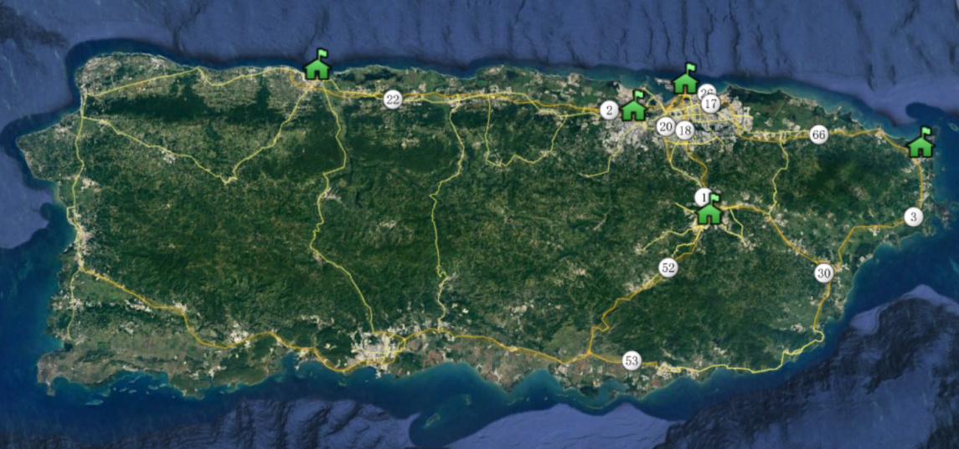

**Figure 5(a):** Puerto Rico Map from Google Earth

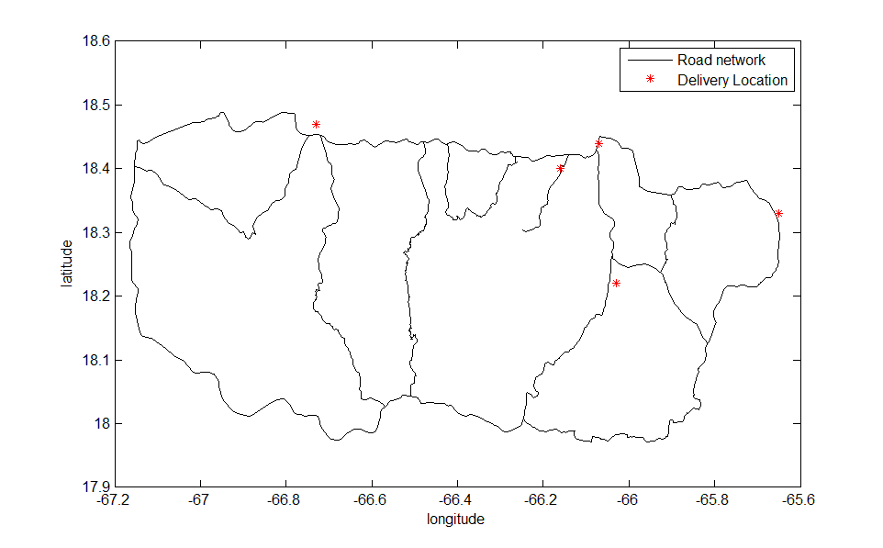

**Figure 5(b):** Puerto Rico Map from MATLAB

We can observe that the eastern and western hospitals are independent and the three hospitals in the central area are densely distributed. In order to determine the Maximum Delivery Range, we make five circles that each hospital as the center of the circle and the maximum transport distance as the radius. We can determine the Maximum Transport Distance by transport requirements. Because the five hospitals of the delivery plan all require MED 1 or MED 3, and we previously assumed that the Emergency Medical Package loaded into Drone Cargo Bay couldn’t be flipped. So that our formation would have to use a Drone Cargo Bay Type 2 drone. We define:



By calculation, the drone C has the largest Voyage. We use the Voyage of the drone C as the radius. Besides, after exporting data from Google Earth, we need to convert its latitude and longitude data into distance data. To do this, we use the following methods:







**Figure 6: Geography Coordinate System**

We define an initial longitude and latitude in the system to get the distance between all path points, the hospital location with the initial latitude and longitude. So that it can be converted into distance data. The initial longitude is -67.2°, the latitude is 17.9°, and the Earth radius R is 6371.393 km, so the longitude distance is:





Finally, we get the following graph:

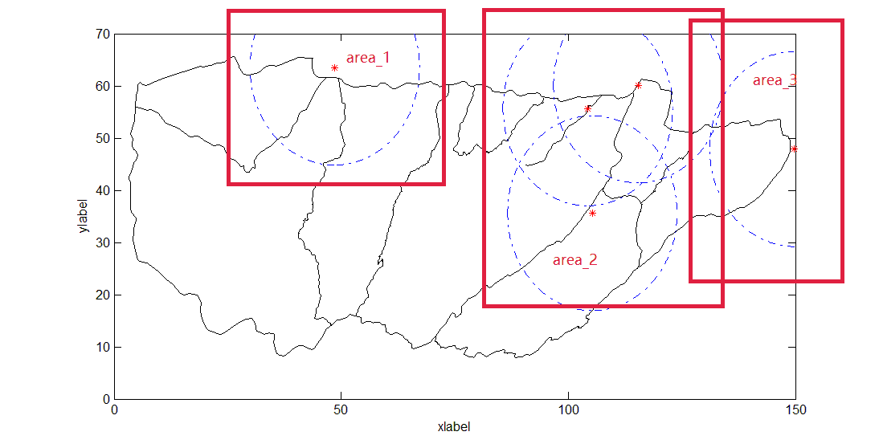

**Figure 7: The Maximum Delivery Range (represent by blue circle) in Each Area**

In the figure 7, we divide the five hospitals into three areas and roughly mark the Maximum Delivery Range with blue circle, named Area_1, Area_2, and Area_3. Obviously, two containers are not able to complete the scheduled works. We must use three containers to be responsible for the delivery and video works of the three areas.

### 4.1.2 Select Candidate Location

We select the candidate locations within the Maximum Delivery Range as the locations of the containers. Containers’ locations have to use the drone to deliver the Emergency Medical Package to the target hospital successfully. At the same time, the drone is required to explore more major highways and roads. So, the farther containers’ locations can make sure the larger exploration range. Our system requires minimal human support and does not affect the urban function. It is better to close to the road. Therefore, we choose the suburbs of the neighboring cities as candidate locations.

### 4.1.3 Best ISO Container Locations on Puerto Rico

Since that there are multiple candidate locations in each area, we need to determine the best ISO container location in each area. Therefore, we make the circles that each candidate location as the center of the circle and the maximum video distance as the radius. We can get the maximum video distance is the drone B’s distance by calculating the attachment 2. Because we intercepted Puerto Rico's main road map from Google Earth with equal length points, we can estimate the total distance of the roads within each candidate location can cover in the circle by calculating the number of points. The biggest point amount of the candidate location is our best ISO container location. Our thoughts can be explained by the following figure:



**Figure 8: Optimal Location Selection**

Circle_1 contains 5 equal length points. Circle_2 contains 3 equal length points. So, choose the center of Circle_1 as our best point. By MATLAB calculations, we get the following results:

**Table 1：**Area_1

|  |  |  |  |
| --- | --- | --- | --- |
| City | Longitude | Latitude | Points_amount |
| Bayaney | 18.3697 | -66.7969 | 713 |
| Camuy | 18.4733 | -66.8619 | 664 |

**Table 2：**Area_2

|  |  |  |  |
| --- | --- | --- | --- |
| City | Longitude | Latitude | Points_amount |
| Bayamon | 18.3672 | -66.1389 | 604 |
| Guaynabo | 18.3350 | -66.0503 | 598 |
| Paseo Alto | 18.2847 | -66.0422 | 659 |

**Table 3：**Area_3

|  |  |  |  |
| --- | --- | --- | --- |
| City | Longitude | Latitude | Points_amount |
| Rio Grancle | 18.3756 | -65.8331 | 591 |
| Daguao | 18.2264 | -65.6808 | 582 |

In this way we can determine the location of the container and the location of the hospital in each area. We summarize them in the following figure:

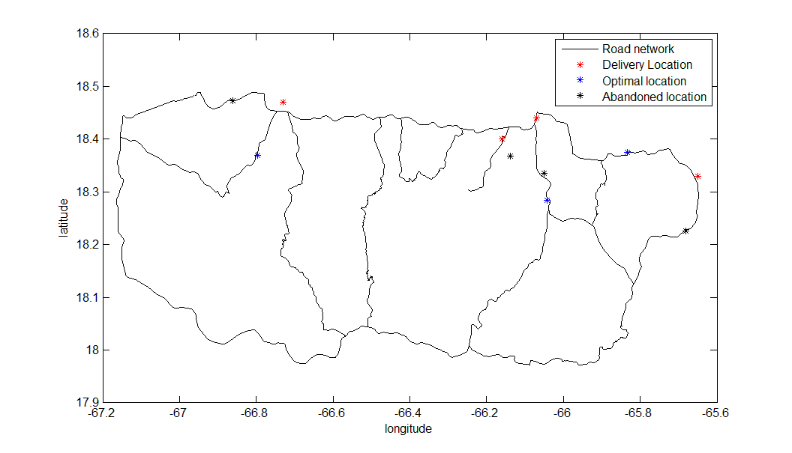

**Figure 9: Hospital and Selected Candidate Locations**

Calculate the distance between optimal location and delivery location in each area. Show in the following table:

**Table 4：The Distance between Optimal Location and Delivery Location**

|  |  |  |  |
| --- | --- | --- | --- |
| Area | Optimal location | Delivery Location | Distance |
| Area_1 | Bayaney | Hospital Pavia Arecibo, Arecibo | 14.2111 |
| Area_2 | Paseo Alto | Hospital HIMA, San Pablo | 8.0478 |
| Hospital Pavia Santurce, San Juan | 18.4774 |
| Puerto Rico Children's Hospital, Bayamon | 13.6333 |
| Area_3 | Rio Grancle | Caribbean Medical Center,Jajardo | 15.2557 |

## 4.2 Construction of Aerial Disaster Relief Response System

### 4.2.1 Composition of Drone Fleet

Through the previous analysis, we obtained the specific location of the container placement location in each area. After that we determined the drone formation and flight plan in each divided area. In each area, a drone formation is used as a basic unit and each drone formation consists of an exploration formation and a delivery formation. A drone formation can satisfy the day's exploration and delivery works.

In the previous section, we have identified three container locations. Considering the complexity of the terrain, such as the cargo route may contain mountains, so the drone’s range will be cut down 2 to 3 kilometers when selecting a drone for hospital delivery. This prevents the drone from returning due to exhaustion. Exploration formations only explore major highways and adjacent cities.

For the drone H Tethered, it can be equipped with a tether that doubles as a power supply and are able to maintain aerial stability. Drone H Tethered can be used to command and monitor other drones. So, we think every container need a drone H Tethered.

Finally, we get the drone formation as following table:

**Table 5: The** **Drone Formation**

|  |  |  |  |  |  |  |
| --- | --- | --- | --- | --- | --- | --- |
| Area | Function | Hospital | Drone Type | Quantity | Medical supply | Quantity |
| Area 1 | Medical supply delivery | Hospital Pavia Arecibo | C | 1 | MED 1 | 1 |
| Video reconnaissance | --- | B | 5 | --- | --- |
| Area 2 | Medical supply delivery | Hospital HIMA | G | 1 | MED 1 | 2 |
| MED 3 | 1 |
| Medical supply delivery | Puerto Rico Children's Hospital | F | 1 | MED 1 | 2 |
| MED 3 | 2 |
| B | 1 | MED 2 | 1 |
| Medical supply delivery | Hospital Pavia Santurce | C | 1 | MED 1 | 1 |
| MED 2 | 1 |
| Video reconnaissance | --- | B | 4 | --- | --- |
| Area 3 | Medical supply delivery | Caribbean Medical Center | C | 1 | MED 1 | 1 |
| MED 3 | 1 |
| Video reconnaissance | --- | B | 2 | --- | --- |

### 4.2.2 Medical Supply Deliver Routes and Schedule

We have determined where the drone formations and containers are placed, and how we plan our flight routes so that we can determine the specific missions and routes of each drone in the drone formation. For the convenience of explanation, we first give the representation of the drone: Take the B model drone as an example, we use B* to indicate the B model drone responsible for transporting the drug, and B- to indicate the B model responsible for exploring the road. In addition, we use B-* to indicate the B model drone that performs the above two tasks.

For the flight routes shown in the picture, we use the following representation: When the drone transports the drug to the hospital, we use purple lines to describe its flight path; when the drone explores the path, we describe it with red lines; When the drone neither explores nor delivers the drug, we use yellow lines to describe its flight path; when the drone returns, we use blue lines to describe its flight path.

Besides, in each road map, we use the coordinates of the green house shape to indicate the hospital to which the drug needs to be delivered. We use the red spindle-shaped coordinate points to indicate the placement of the container, where A represents Bayaney in Area_1, B represents Paseo Alto in Area_2, and C represents Rio Grancle in Area_3.

In this way, for the drone that transports drugs in the drone formation, we can get the following flight schedule:

**Table 6:** Medical Supply Deliver Schedule

|  |  |  |  |  |  |
| --- | --- | --- | --- | --- | --- |
| Area | Hospital | Drone | Quantity | Medical supply | Quantity |
| Area_1 | Hospital Pavia Arecibo | C-* | 1 | MED 1 | 1 |
| Area_2 | Hospital HIMA | G* | 1 | MED 1 | 2 |
| MED 3 | 1 |
| Puerto Rico Children's Hospital | F* | 1 | MED 1 | 2 |
| MED 3 | 2 |
| B-* | 1 | MED 2 | 1 |
| Hospital Pavia Santurce | C* | 1 | MED 1 | 1 |
| MED 2 | 1 |
| Area_3 | Caribbean Medical Center | C* | 1 | MED 1 | 1 |
| MED 3 | 1 |

B* indicates the B model drone that transports the drug, B- indicates the B model drone that explores the path, and B-* indicates the B model drone that both tasks are executed.

The routes corresponding to each drone in the flight schedule is displayed as follows：

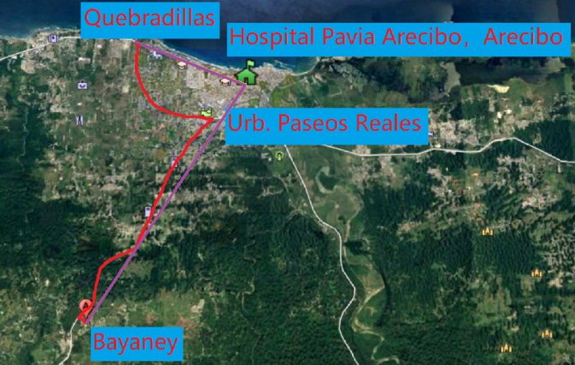

**Figure 10(a):** C-* in Area_1

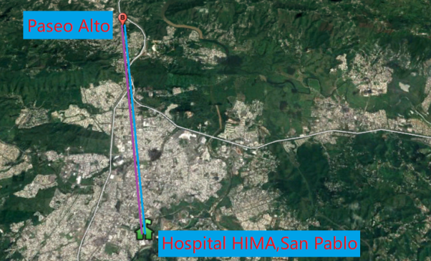 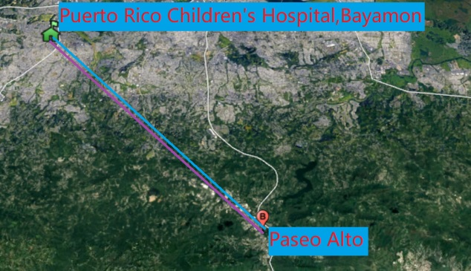

**Figure 10(b):** G* in Area_2 **Figure 10(b):** F* in Area_2

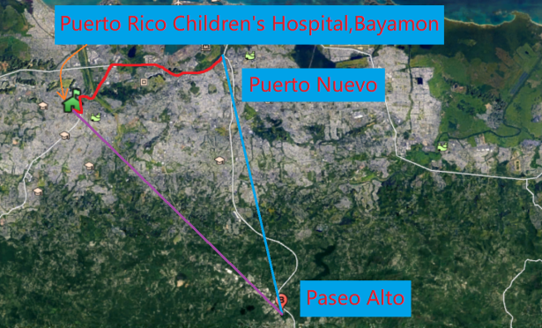 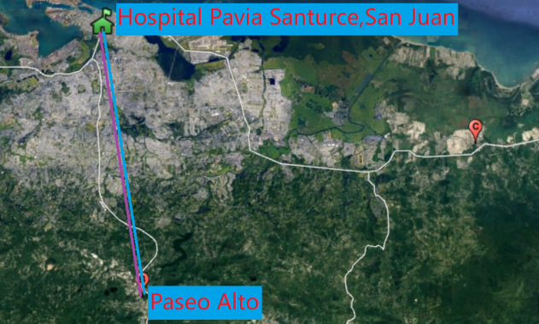

**Figure 10(d):** B-* in Area_2 **Figure 10(e):** C* in Area_2

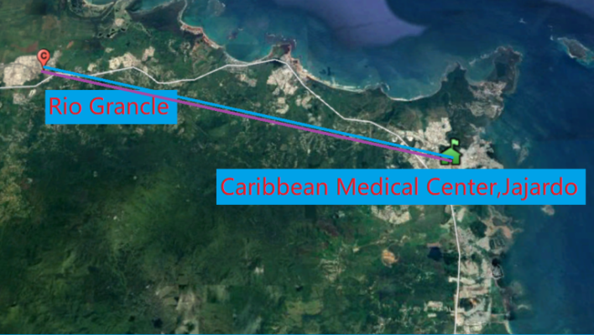

**Figure 10(f):** C* in Area_3

### 4.2.3 Flight Plan for Reconnaissance of Major Highways and Roads

Similarly, for a drone that explores the path in a drone formation, we can get a similar flight schedule. Due to the use of multiple drones of the same model, we also numbered the drones separately for easy distinction. For example, the first B model drone in Area_1 is represented as B_1-. Finally, we get the following flight schedule:

**Table 7:** Video Reconnaissance Schedule

|  |  |
| --- | --- |
| Area | Drone |
| Area_1 | B_1- |
| B_2- |
| B_3- |
| B_4- |
| B_5- |
| Area_2 | B_1- |
| B_2- |
| B_3- |
| B_4- |
| Area_3 | B_1- |
| B_2- |

B_1- indicates the B model drone that explores the path in the area.

The routes corresponding to each drone in the flight schedule is displayed as follows：

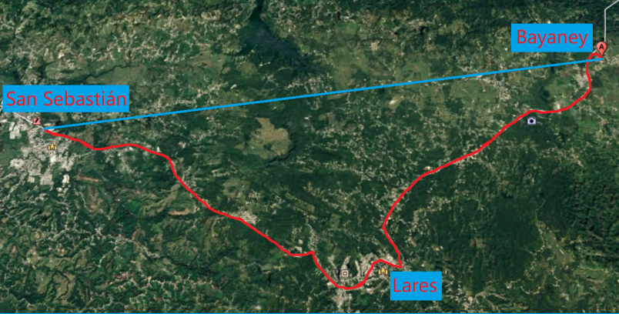

**Figure 11(a):** B_1- in Area_1

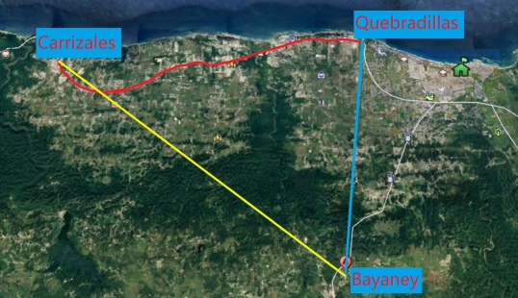 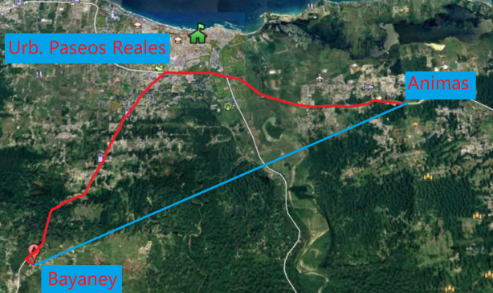

**Figure 11(b)**: B_2- in Area_1 **Figure 11(c):** B_3- in Area_1

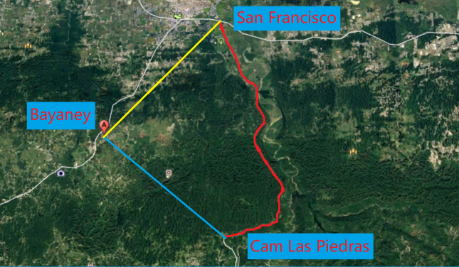 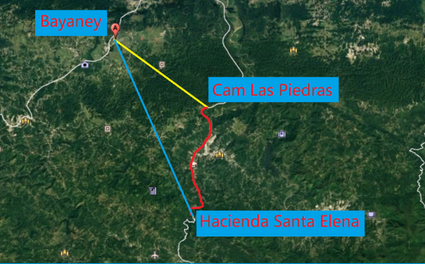

**Figure 11(d):** B_4- in Area_1 **Figure 11(e):** B_5- in Area_1

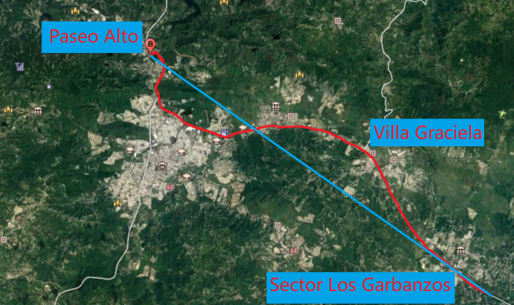 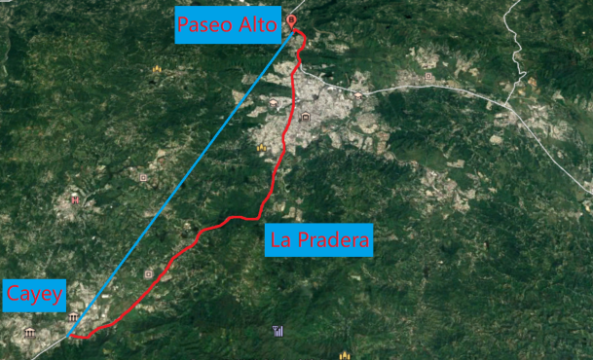

**Figure 11(f):** B_1- in Area_2 **Figure 11(g):** B_2- in Area_2

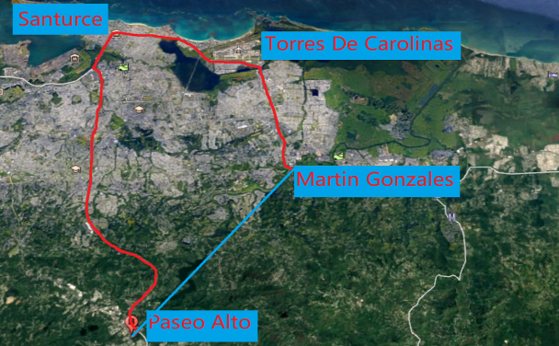 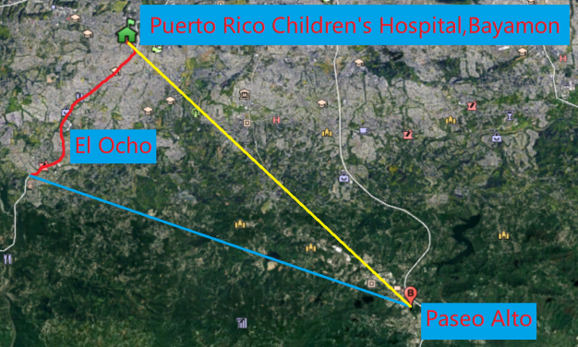

**Figure 11(h):** B_3- in Area_2 **Figure 11(i):** B_4- in Area_2

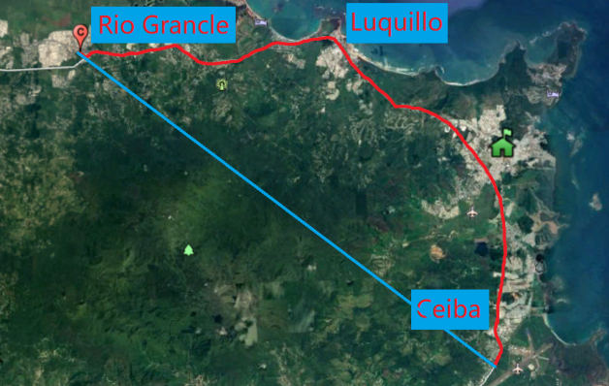 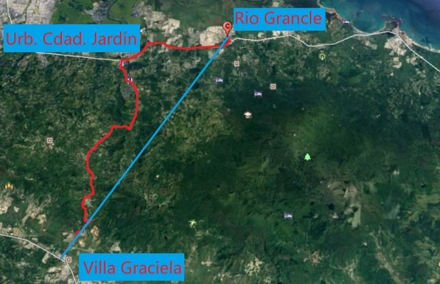

**Figure 11(j):** B_1- in Area_3 **Figure 11(k):** B_2- in Area_3

### 4.2.4 Packaging Strategy with Minimized Unused Space

The optimal packaging strategy will be calculated from the model that explained in chapter 3. When we know number of drones and Emergency Medical Packages, we can use this algorithm to get the most efficient utilization and the least unused space.

We think that the standard packing strategy should satisfy N times the daily flight formation. This strategy can complete N days of Emergency Medical Packages delivery and exploration tasks. Based on the previous flight formation design, we get a standard packing combination. As shown in the following figure:

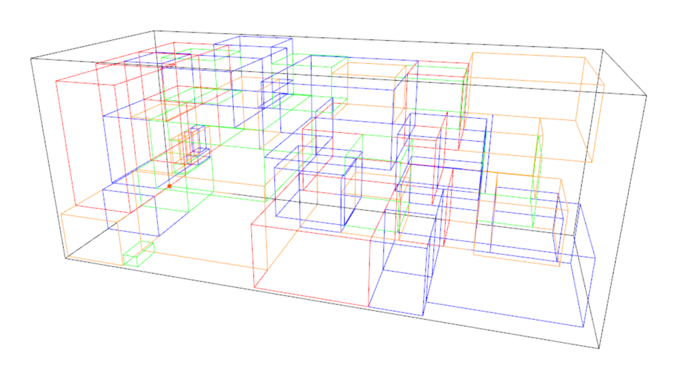

**Figure 12(a): Area_1**

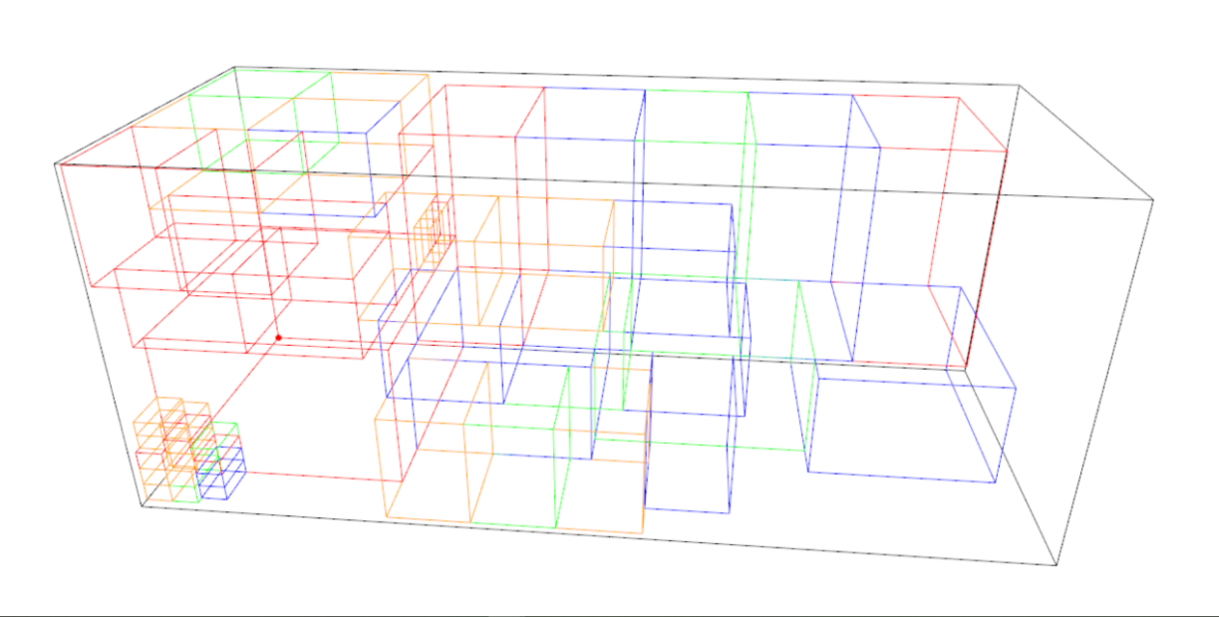

**Figure 12(b): Area_2**

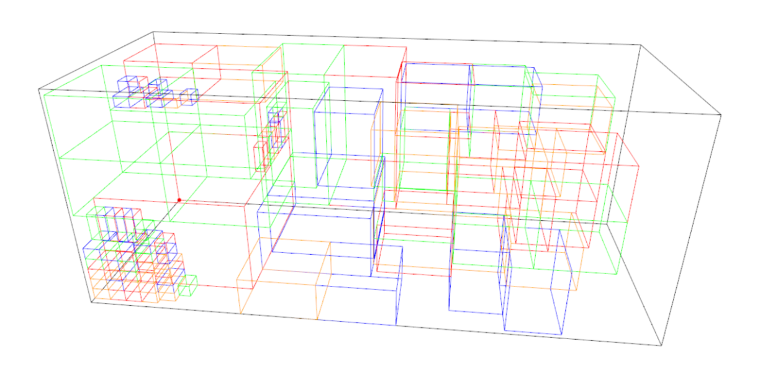

**Figure 12(c): Area_3**

After completing the standard strategy of packing tasks, the container still has some free space. Based on the following considerations, we propose optimization of the packaging strategy:

* As much as possible to satisfy the needs of hospitals, we should increase the number of drug delivery drones and drugs.
* For the three hospitals in Area_2, we try our best to satisfy the needs of the Puerto Rico Children's Hospital:

1. Out of humanitarianism, this is the only children’s hospital in Puerto Rico,
2. In our strategy, the drone B could deliver Emergency Medical Packages to this hospital and explore road together.

We put our ideas into the R program again. We find that we can optimize Area_1 and Area_2. The results are shown below:

**Table 8: Standard and Optimize Strategy**

|  |  |  |  |  |  |
| --- | --- | --- | --- | --- | --- |
| Area | Area_1 | | Area_2 | | Area_3 |
|  | Standard | Optimize | Standard | Optimize | Standard |
| B | 35 | 35 | 25 | 28 | 18 |
| C | 7 | 8 | 5 | 5 | 9 |
| F | 0 | 0 | 5 | 8 | 0 |
| G | 0 | 0 | 5 | 5 | 0 |
| H | 1 | 1 | 1 | 1 | 1 |
| MED1 | 7 | 8 | 25 | 31 | 9 |
| MED2 | 0 | 0 | 10 | 13 | 0 |
| MED3 | 0 | 0 | 15 | 21 | 9 |
| Volume | 1526305 | 1616795 | 1451205 | 1636161 | 1373709 |
| Space Utilization Ratio | 76.4% | 80.9% | 72.6% | 81.9% | 68.8% |

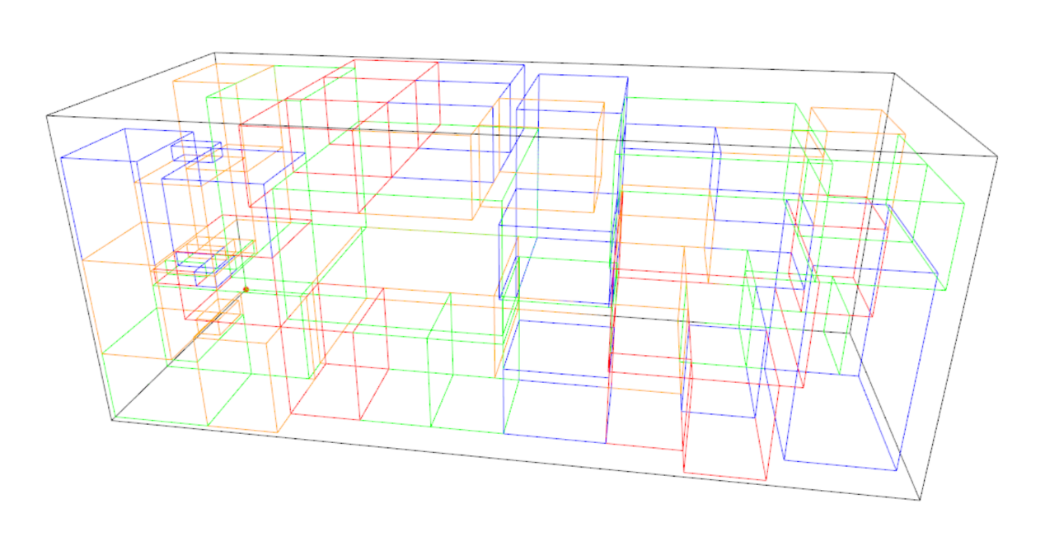

**Figure 13(a)：Optimized Area_1**

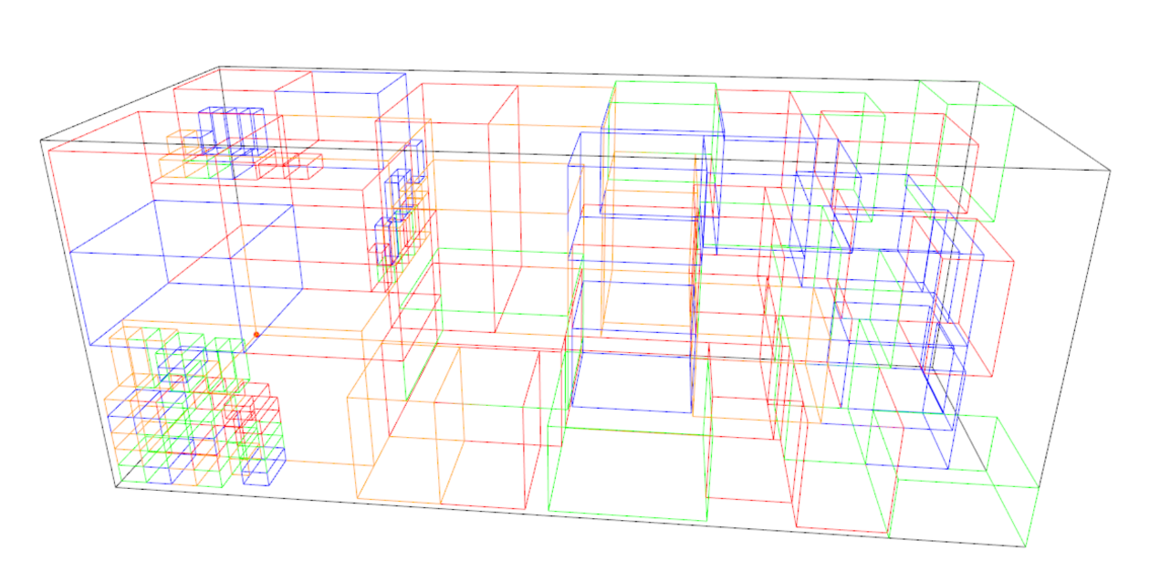

**Figure 13(b)：Optimized Area_2**

# V. Strengths and Weaknesses

## 5.1 Strengths

* We determine the location of the container according to the actual situation.
* The flight route is given in Google Earth so that it’s easier to actually operate.
* The packing situation is displayed in a perspective view, which is clear and thorough.
* The combination of the Heuristic Packing Strategy and Genetic algorithm improves computational efficiency and accuracy.

## 5.2 Weaknesses

* The various parameters of the Genetic algorithm are artificially set, so the accuracy is relatively low.
* There is still space available in each container.
* In more complex environments, the system may not be applicable.

# References

[1] Wang, H., Chen, Y., 2010. A hybrid genetic algorithm for 3d bin packing problems. In: Bio-Inspired Computing:Theories and Applications (BIC-TA), 2010 IEEE Fifth International Conference on. IEEE, pp. 703–707.

[2] Lai, K., Chan, J.W., 1997. Developing a simulated annealing algorithm for the cutting stock problem. Computers & industrial engineering 32 (1), 115–127.

[3] Gonçalves, J. F., Resende, M. G., 2013. A biased random key genetic algorithm for 2d and 3d bin packing problems. International Journal of Production Economics 145 (2), 500–510.

# Memo

**To:** Karen Rasmussen, Chief Operating Officer of HELP, Inc.

**From:** MCM team

**Date:** January 28, 2018

**Subject:** Recommendations of Aerial Disaster Relief Response System

Our team has completed a transportable disaster response system design for your company to provide adequate and timely response after the hurricane struck the Puerto Rico in 2017 or possible future disaster.

First, we separated five hospitals into three areas and located three best points for ISO shipping container as the base station in order to conduct disaster relief action. Then, for each area, we designed a independent fleet which consist of different UAV and assorted medical supplies. Finally, the optimal packaging strategies are gained by our modified genetic algorithm with maximum utilization. All flight plans are also available alone with the geographic map. Our system can satisfy up to 9 days` demand of medical supply and can reconnoitre the major highway over 3400km.

Three locations (red sign) of ISO cargo containers and reconnaissance range are as follow:

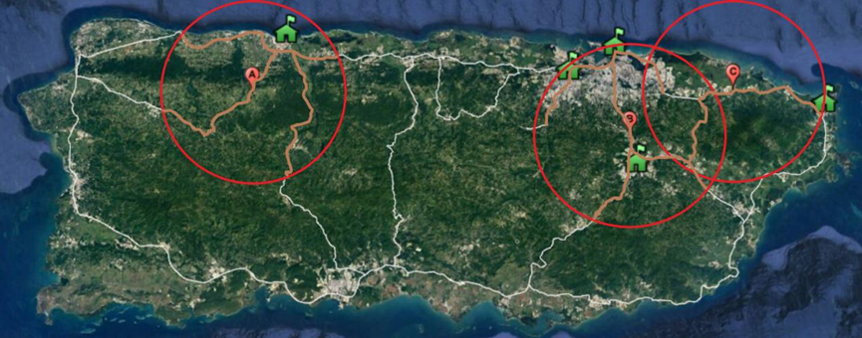

It is suggested that each ISO cargo should contain a drone H as the command station, several drone B as the reconnaissance fleet and the smallest drone type which can meet the medical supply demand.

|  |  |  |  |  |  |  |
| --- | --- | --- | --- | --- | --- | --- |
| Area | Medical supply delivery | Quantity | Video reconnaissance | Quantity | Basement | Quantity |
| Area 1 | C | 1 | B | 5 | H | 1 |
| Area 2 | G | 1 | B | 4 | H | 1 |
| F | 1 |  |
| B | 1 |  |
| C | 1 |  |
| Area 3 | C | 1 | B | 2 | H | 1 |

Notice that this diagram only represents the daily demand of the drones. In next diagram, we will show how many days can we support the relief action by one ISO cargo.

Based upon our selection model, we conduct the modified Genetic algorithm (GA) model to obtain the quantity of relief supplies and packing method. Hereby we propose the optimal packaging strategy for Aerial Disaster Relief Response System.

|  |  |  |  |  |  |
| --- | --- | --- | --- | --- | --- |
| Area | Area_1 | | Area_2 | | Area_3 |
|  | Standard | Optimize | Standard | Optimize | Standard |
| B | 35 | 35 | 25 | 28 | 18 |
| C | 7 | 8 | 5 | 5 | 9 |
| F | 0 | 0 | 5 | 8 | 0 |
| G | 0 | 0 | 5 | 5 | 0 |
| H | 1 | 1 | 1 | 1 | 1 |
| MED1 | 7 | 8 | 25 | 31 | 9 |
| MED2 | 0 | 0 | 10 | 13 | 0 |
| MED3 | 0 | 0 | 15 | 21 | 9 |

|  |  |  |  |
| --- | --- | --- | --- |
| Standard supply time | 7 days | 5 days | 9days |

|  |  |  |  |  |  |
| --- | --- | --- | --- | --- | --- |
| Volume | 1526305 | 1616795 | 1451205 | 1636161 | 1373709 |
| Space Utilization Ratio | 76.4% | 80.9% | 72.6% | 81.9% | 68.8% |

As you can see, we give you here both standard and optimized scheme. The latter one is designed for the particular situation in Puerto Rico 2017. We highlighted the quantity change of drone or medical package.

We hope that our suggestion can provide useful information for you.

Yours sincerely,

Team #1925762